2021 WESTSIDE INVITATIONAL SOCCER TOURNAMENT
Rules and Regulations of Competition
June 11 - 13, 2021

RULE I - GAME LENGTH & FORMAT: There will be NO OVERTIME in any pool play game and the game can end in a tie. There will be a 5-minute interval at the half. The home team is listed on the schedule first, they will have field side selection and provide two approved game balls. In the event the uniform color is in conflict the home team must change. Teams will sit on opposite sides of the fields along with their spectators.

Age Group | Format | Roster Size | Length | Size Ball
U4 – U8 | Youth Clinic | N/A | 60 minutes | 3
U9 | 7 v 7 | 14 | (2) 25 Minute Halves | 4
U10 | 7 v 7 | 14 | (2) 25 Minute Halves | 4
U11 | 9 v 9 | 18 | (2) 30 Minute Halves | 4
U12 | 9 v 9 | 18 | (2) 30 Minute Halves | 4
U13-19 | 11 v 11 | 22 | (2) 30 Minute Halves | 5
RULE II - PLAYER PASSES/BOOKS and GUEST PLAYERS: The ONLY acceptable proof of age will be a VALID USSF, state, or national/province pass/book that includes the signature and photograph of the player. Players not presenting a VALID player pass/book at registration will not play. At any time, a player pass must be available for viewing during ALL games by a referee, or tournament director. Rosters may include up to three (3) guest players. These guest players SHALL replace players who could not attend the tournament. Rosters may not be changed after tournament registration. At no time, may any player(s) in this Tournament register or play for more than one tournament team. Any player(s) found doing so will be removed from the Tournament. Any team using a player either not validated at registration or dual-rostered, will forfeit all games in which the player(s) participated and such conduct will be reported to its respective state/provincial soccer association. Passes may be checked prior to championship matches as well as any other pool play game.
RULE III - SUBSTITUTIONS: There is no limit to the number of substitutions per game. Referee approval is required for any substitution. Prior to own team’s throw in, prior to a goal kick, after a goal, during halftime, and injury to player are all in effect with referee approval. For the U8-U10 age group, you may substitute a player on any stoppage of play.

RULE IV - FOULS and MISCONDUCT: COACHES MAY BE DISMISSED FROM A MATCH. Player passes/books In the event a player receives a "RED CARD" or a coach is dismissed, the Field Marshal will turn in the player's pass/book and report the infraction or the dismissal to the Tournament Director at headquarters. “YELLOW CARD” Any player receiving 1 yellow card during play are not required to leave the field of play. Players receiving 2 yellow cards in one game are awarded a “RED CARD” and subject to all rules concerning red cards. Yellow cards do not carry over from one game to the next. Any player receiving a
"RED CARD" or any coach who has been dismissed will not be allowed to participate in the following game. The Tournament
Director will deny further participation for the remainder of the Tournament in the event any individual receives a second "RED
CARD" or dismissal. "RED CARDS" and dismissals will be reported to the New York State West Youth Soccer Association (NYSWYSA). Passes/books will be held at Tournament headquarters until the suspension is fulfilled. Passes/books held at headquarters as a result of "last game RED CARDS" will be sent to the NYSWYSA Rochester Commissioner and held until the suspension is served. NYSWYSA will communicate and forward any passes/books held to the visiting player/coach home association. Any incident of referee assault (or abuse) will, in accordance with USSF Rule 3042, be referred immediately to NYSWYSA. Home state/provincial associations and the home club/league shall, except in the case of referee assault, have the responsibility for imposing, should circumstances warrant, additional sanctions within their respective jurisdiction with regard to any matters arising from the Tournament.

RULE V - FORFEITS: In the event a team does not appear at the scheduled game time or leaves the field before conclusion of a game, a 3-0 score/win will be awarded its opponent at the discretion of the Tournament Director. All teams must be at their assigned field at least 15 minutes before the start of their games. Teams not at their assigned fields 10 minutes after the scheduled start will forfeit that game. All decisions of the Tournament Director and the Resolution Committee are final. Teams
not properly registered before the start of their first game will forfeit all games until proper registration and paperwork are
completed. IN NO CASE, SHALL A TEAM WHICH FORFEITS A GAME BE CONSIDERED FOR A PLAY-OFF POSITION OR BE CONSIDERED A DIVISION CHAMPION, FINALIST, OR RUNNER-UP.

RULE VI - STANDINGS:
WIN = 3 points, TIE = 1 point, LOSS = 0 points. Shut Out: 1 point (0-0 is not considered a shut out)

Player Red Card, Head Coach or Assistant Coach Ejection = minus 1 point for each occurrence

Standings in a division will be determined by points accumulated; points accumulated in "crossover" play against teams in other divisions (if any) also count when determining standings within one's own division. The method of determination of division champion and runner-up in each division will be as specified by the Tournament Director, in most cases, the top two teams in the division at the end of round robin play will play again for the championship. In some divisions, there may be a third place game as well. Games scores on which these points are based MUST BE VERIFIED at the end of each game by the referee's signature on the scorecard. In the event of teams being equal in points after the division's games are completed, standings will be determined as follows (note, however, Rule V - Forfeits, which takes first priority):

- If 2 teams are tied, the result of head-to-head competition (if 3 or more teams are tied, skip to #2 below); if still equal, then:
- The number of goals against; if still equal then;
- The team with the most wins, if still equal, then:
- The goal differential for EACH WIN (maximum of plus 3 per win); if still equal, then:
- The most shut-outs; if still equal, then:
- FIFA penalty kicks tie-breaking procedure under the supervision of the head referee.

Ties at the end of regulation time in championship: semi-final or play-off games (where applicable) will be broken by the FIFA penalty kicks tie-breaking procedure; there are no overtimes. Note that, for example, if a 3-way tie for a championship finalist is broken in favor of one team using these procedures, then only 2 teams remain tied for the second tournament finalist slot; the tie-break between these two teams is then decided all over again starting with step #1 above. Awards will be presented, as a minimum, to division champions and runners-up. Standings will not be kept in U-8, U-9 and U-10 divisions; participation awards will be presented to all players in U-8, U-9 and U-10 divisions.

RULE VII – INCLEMENT WEATHER: Coaches and players must appear on the field ready to play at their scheduled time, regardless of weather conditions, unless advised otherwise by the Tournament Director. Only the referee or the Tournament Director may cancel or suspend a game. In the event of inclement weather before a game, referees or the Tournament Director may delay the game or reduce its length by 50%; furthermore, the Tournament Director may, at her sole discretion, reduce the length of subsequent games on the schedule by up to 50% and/or change scheduled field locations if deemed necessary to complete the entire schedule by the end of the day due to the impact of extended inclement weather. If a game in progress is terminated due to weather conditions and one half of the game has been completed, then that game will be considered official and the score final.

RULE VI11 - TEAM SIDES OF THE FIELD: Teams shall be on opposite sides of the pitch, with home team choosing the side. Each team and its fans must occupy the same side of the field when space allows. If the pitch has stadium seating the teams should sit on opposite sides of the center of the field with reasonable room between the spectators. Referees will be instructed not to begin the game until teams and fans comply with this rule. No players or fans are permitted behind the goals at any time during the game. Any discrepancies are to be addressed prior to the start of the game with the Field Marshal, who will in turn contact the tournament director and please note that at that time their decision will be final.

RULE IX - PLAYER EQUIPMENT: Players must wear shin guards and proper uniforms in accordance with FIFA, USSF, and NYSWYSA guidelines. The "Home" team as specified on the schedule has first choice of uniforms; the "Visiting" team will wear its uniform which contrasts with that of the "Home" team. In the event that the "Visiting" team does not have a uniform which contrasts sufficiently with that of the "Home" team in the opinion of the referee, both teams will cooperate and change uniforms as necessary in order that the game may proceed. The "Home" team will provide a ball for the game, size 4 for U12 and younger, size 5 for all other age groups.

RULE X - PERSONAL CONDUCT: The Tournament will not tolerate discriminatory acts by any Tournament participant
(coach/player/supporter), with respect to race, color, religion or national origin. Alcohol consumption or the use of illegal drugs by any participant, coach, team, or supporter during the Tournament will not be tolerated. Any such act shall constitute
unsportsmanlike conduct. Any such participant, coach, team parent, team supporter, and/or the entire team (a) will be subject to immediate dismissal from the Tournament at the sole discretion of the Tournament Director; (b) may be held liable; and/or (c) may be barred from any future Spencerport functions.

RULE XI - PROTESTS: Referee decisions are final and are not subject to protest.

RULE XII - RESOLUTION COMMITTEE: The Resolution Committee shall consist of the Tournament Co-Directors and one representative from the Scoring Committee. The Resolution Committee reserves the right to decide on all matters pertaining to the Tournament, including interpretation of the foregoing Rules and Regulations of Competition. In the event that a situation occurs which is not covered by or is ambiguous in the Tournament Rules and Regulations of competition, that situation will revert to the Resolution Committee for a decision based upon the spirit and intent of that situation. The issue that is to be resolved must be submitted in writing with a bond check of $100 to the tournament director. The fee will be refunded if it is decided by the committee that the issue brought forth is upheld. The decisions of the Resolution Committee are final.

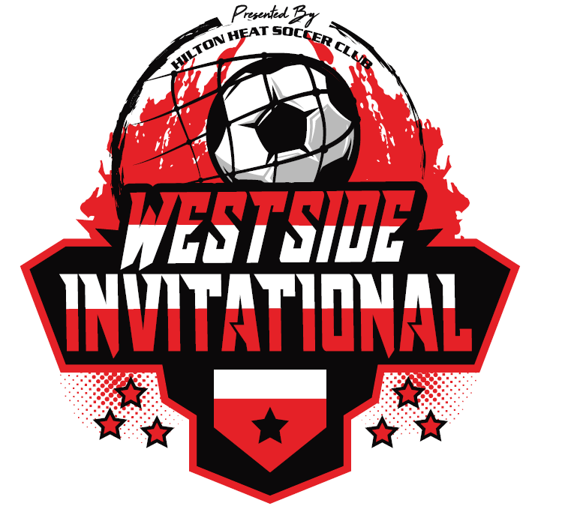

Rules Acknowledgement Form

This document is to acknowledge the fact that the head coach of the ______________________________ (include age and gender) team has read and understands the rules of the 2021 Westside Invitational Soccer Tournament. This form is to be signed and turned in at your team’s registration.

A written copy of the official tournament rules can be viewed and printed at www.hiltonheat.com under the tournament information tab.

x

Signature of Head Coach, Assistant Coach or Team Manager

Thank you in advance for your support with this and we look forward to being your host this year!

Sincerely,
Kerry Frear-Caliri
Tournament Director

